First – Project – Raven Website

This website was developed to promote the band Raven.
Raven are a Heavy Metal band who formed in 1974 who still tour and release albums to this day.

I’ve written this website to promote the band and give fans access to an further information they wish to obtain about the band.

Also fans are given multiple ways to contact the band as well as the ability to enquire about booking the band.

The following User Stories were used:

User Story

Heavy Metal Fan

A Heavy Metal fan who is interested in the band and wants to know the following information:

History of the Band

Discography

Blog – Contains Messages from the band themselves with archived information

Tour Dates

Contact / Booking Form

Links - Links to other sites with information about the band

Media – Audio Files, Videos and photos of the bandmates

He also wasnt to be able to Contact the band

There is also a Home (Index) page with latest news/latest blog and links to the rest of the site and Social Media links.

Promoter / Fan

This is a User who wants more information about the band and wishes to book the band.

The Contact / Booking page facilitates this.

Home Page / Index

As part of the design it was decided to use an image of the artwork of a Raven album as a frame for the page. Different modified versions of this image were used as a background for the other pages.

Every page has a Navigation Bar and Social Media Links at the top and a Footer at the bottom with Copyright and a Link to Contact Information.

The Home Page has Latest News, Latest album and Lated Blog Information as well as the above links.

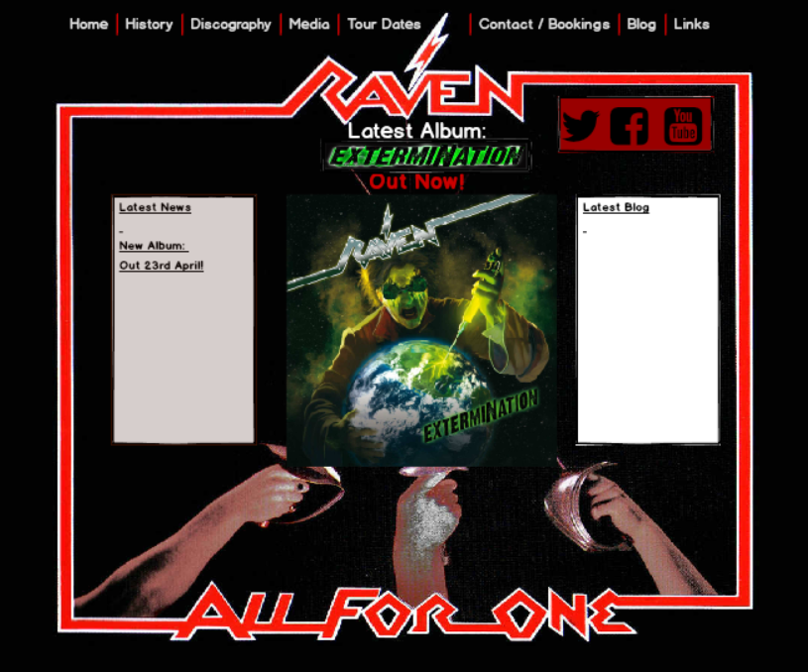

History of the Band

This page will show the History of the band, how they formed, how they evolved, previous members of the band and current members. Also who playes what Instrument.

A prototype screen was developed and this is shown below:

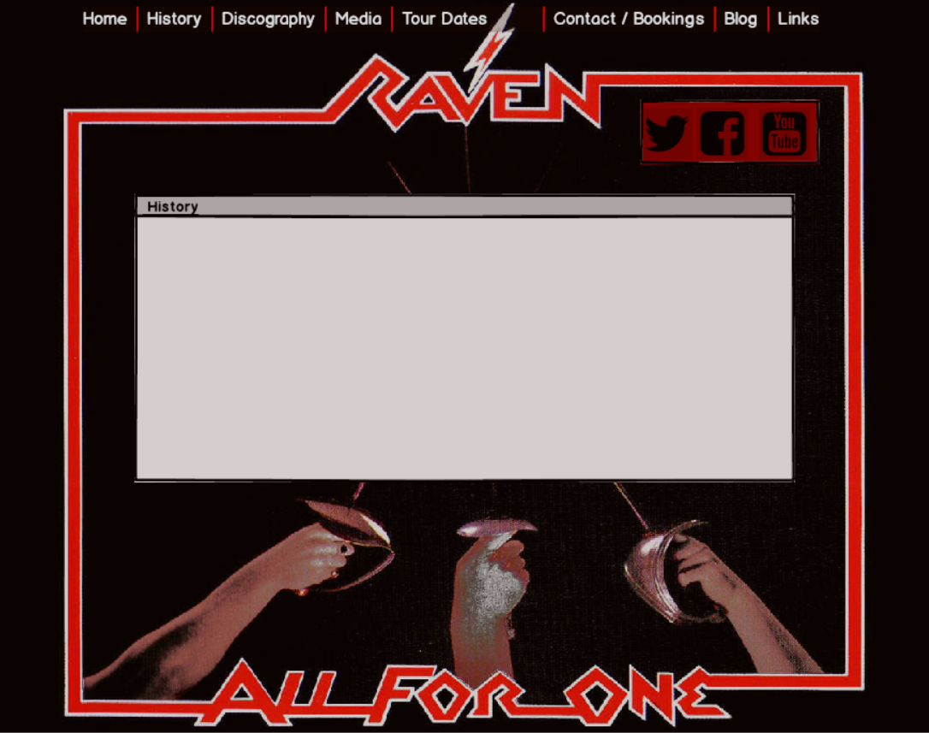

Discography

The Discography shows the User a complete list of material released by the band as well as Label / Year and chart position

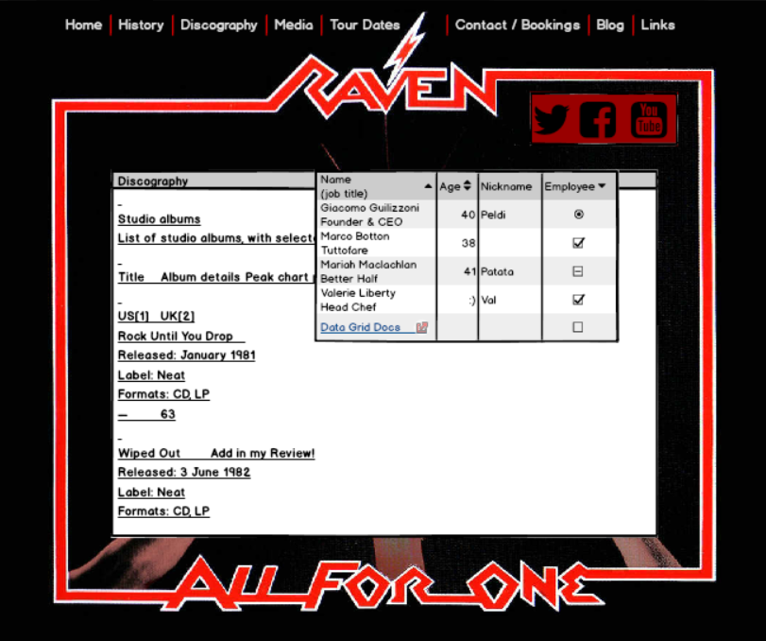

Media

This page will contain, playable Audio files, Video content and photos of the band.

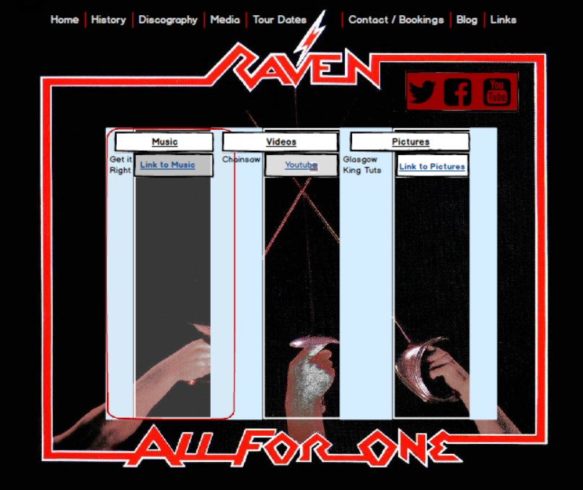

Tour Dates

This page will inform the user of Location and Date of gigs in the current tour with the support act.

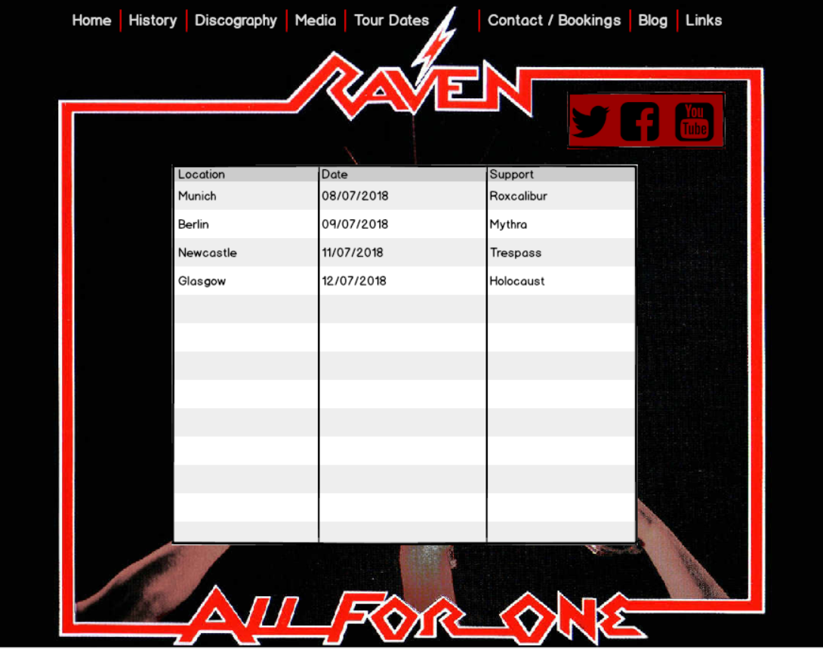

Contact / Bookings

This page will inform the user of contact details for the band as well as a Booking Form to request booking the band to play a venue.

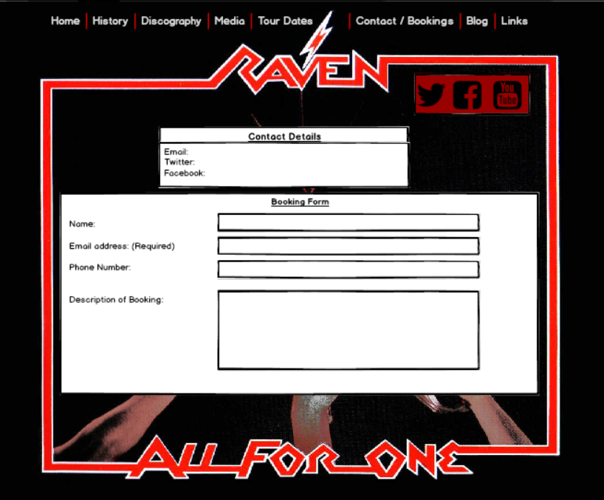

Blog

Details of the latest Blog from the band and an accessible archive of previous Blogs.

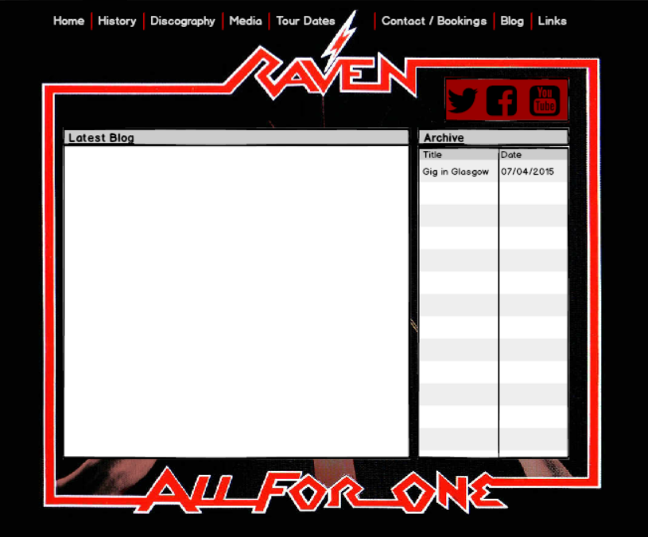

Links

Links to external sites with information about the band

